Window Function:
1] Row Number(on Employee table)
Purpose: Assigns a unique number to each row.
select * from employee;
select *, row_number() over (order by salary DESc) as RankNo from employee;
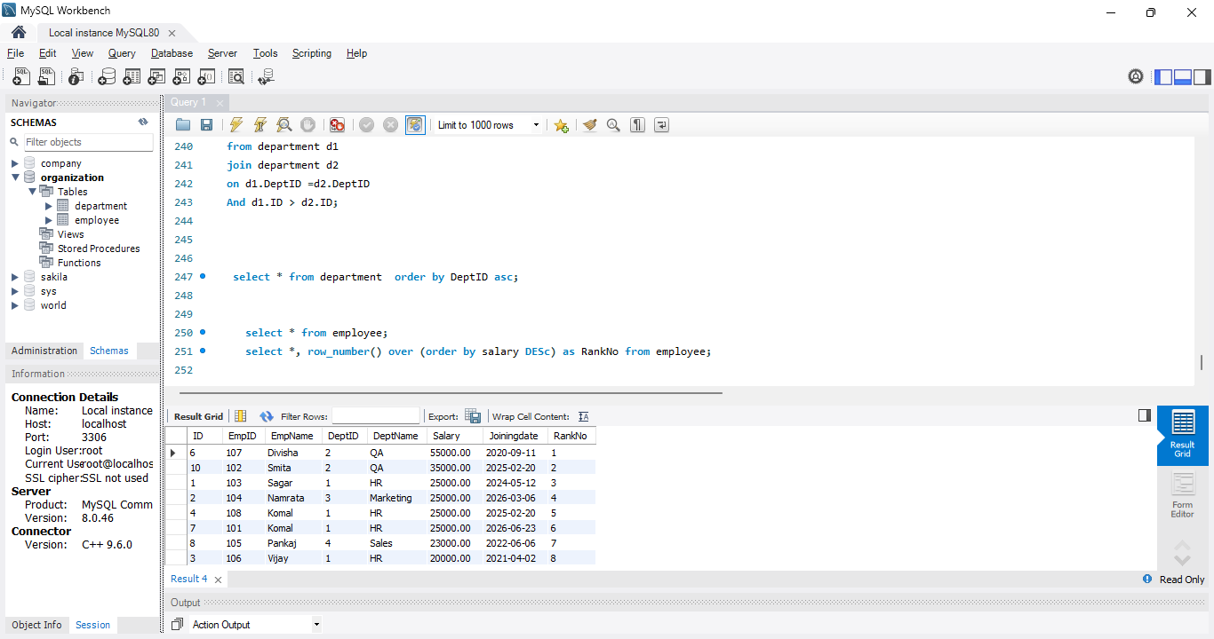

2] On department table
select * from department;
select *, row_number() over (order by DeptName DESc) as RankNo from department;
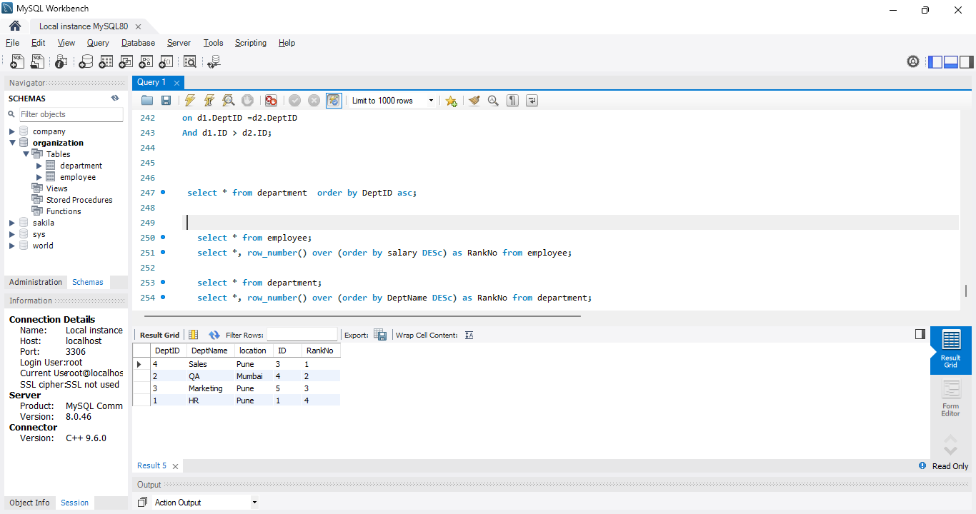

- Row Rank: Purpose: Assigns the same rank to duplicate values.
SELECT *,
RANK() OVER(ORDER BY Salary DESC) AS RankNo
FROM Employee;
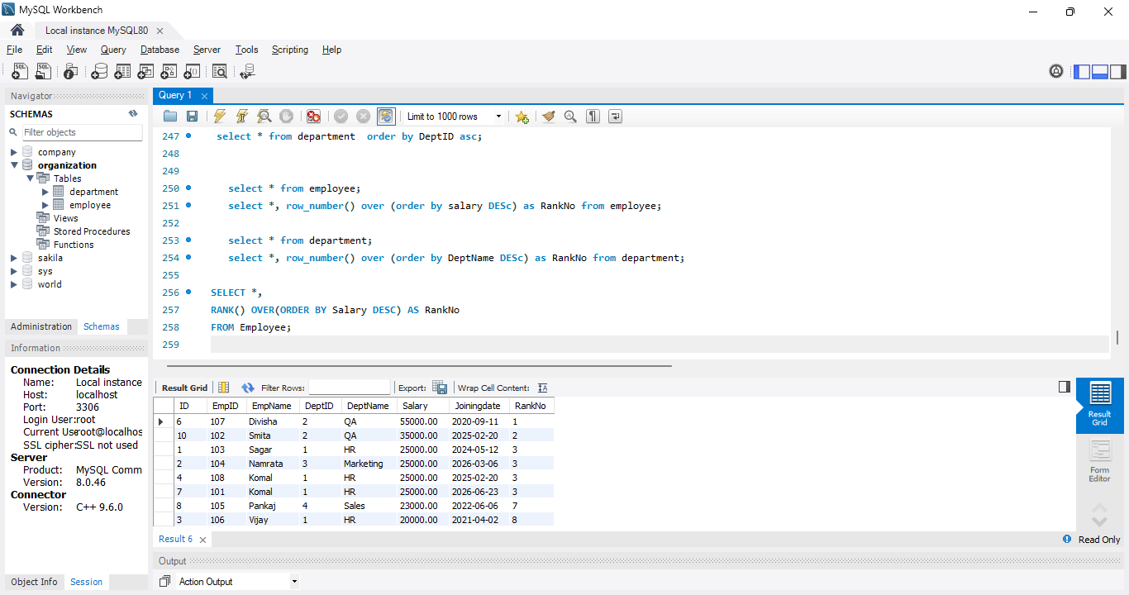

2]SELECT *,
RANK() OVER(ORDER BY DeptName DESC) AS RankNo
FROM Employee;
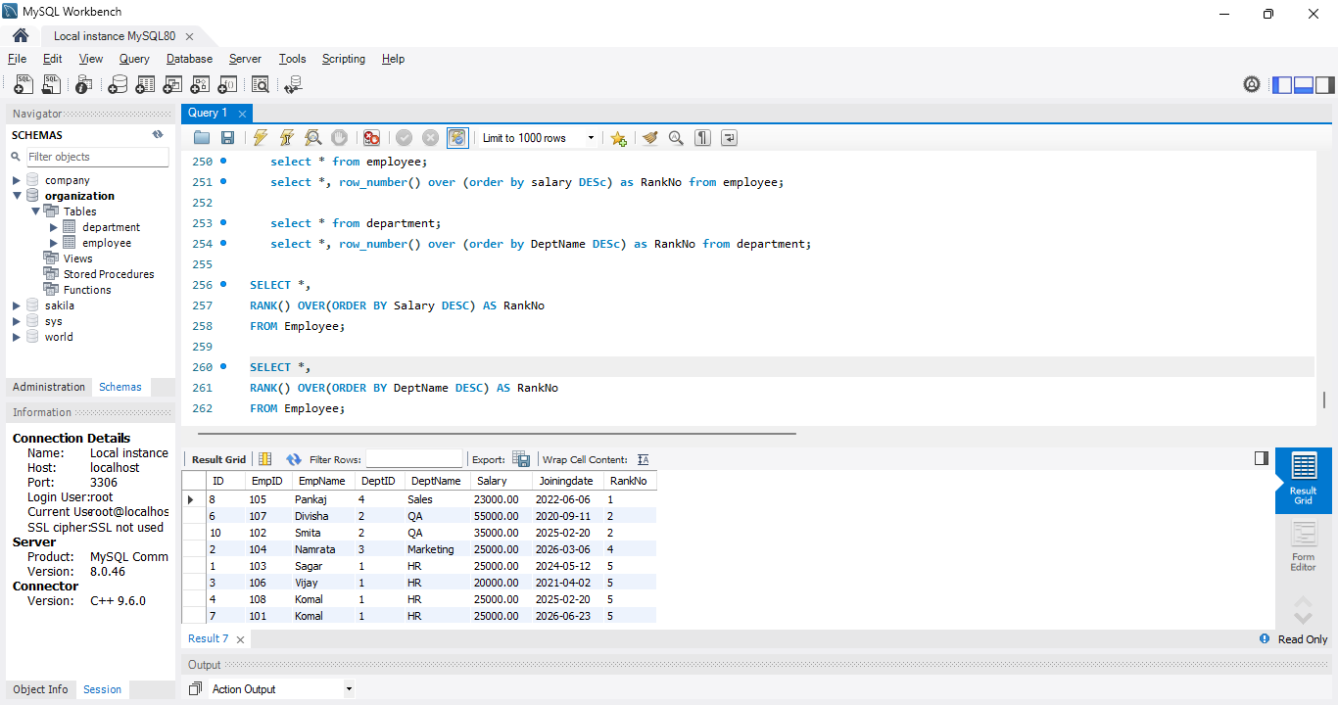
3]deparment table:
SELECT *,
RANK() OVER(ORDER BY location DESC) AS RankNo
FROM Department;
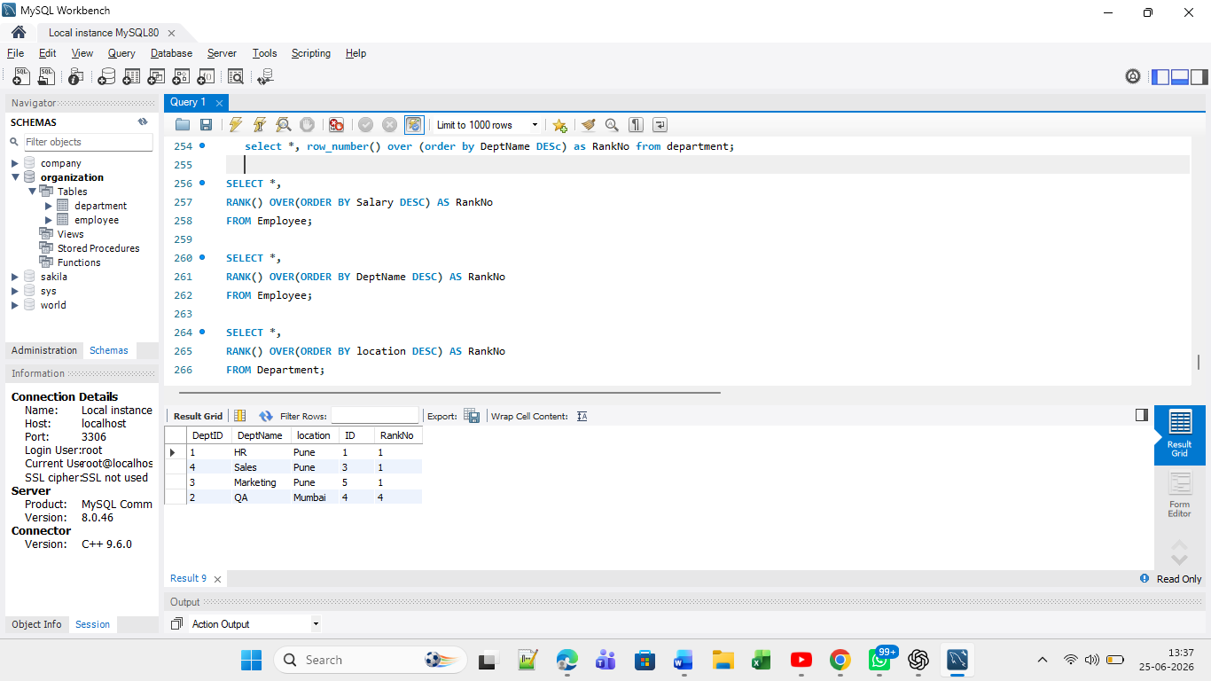

- 3]DENSE_RANK() assigns the same rank to rows with the same value and does not skip the next rank.

SELECT *,
dense_rank() OVER(ORDER BY DeptName DESC) AS DenseRankNo
FROM Employee;

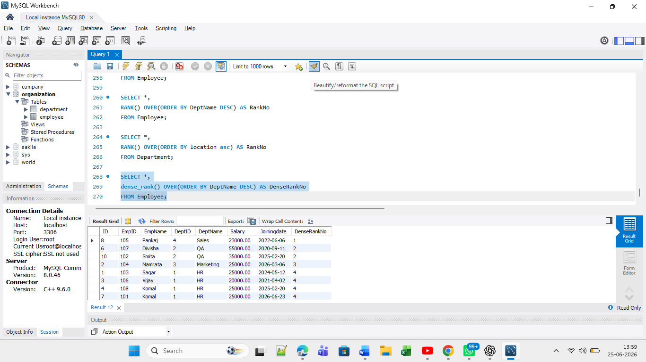

DENSE_RANK() assigns the same rank to duplicate values without leaving gaps in the ranking sequence.

4} NTILE(NTILE(n) divides the result set into n approximately equal groups (buckets).")
SELECT EmpName,
Salary,
NTILE(2) OVER (ORDER BY Salary DESC) AS GroupNo
FROM Employee;
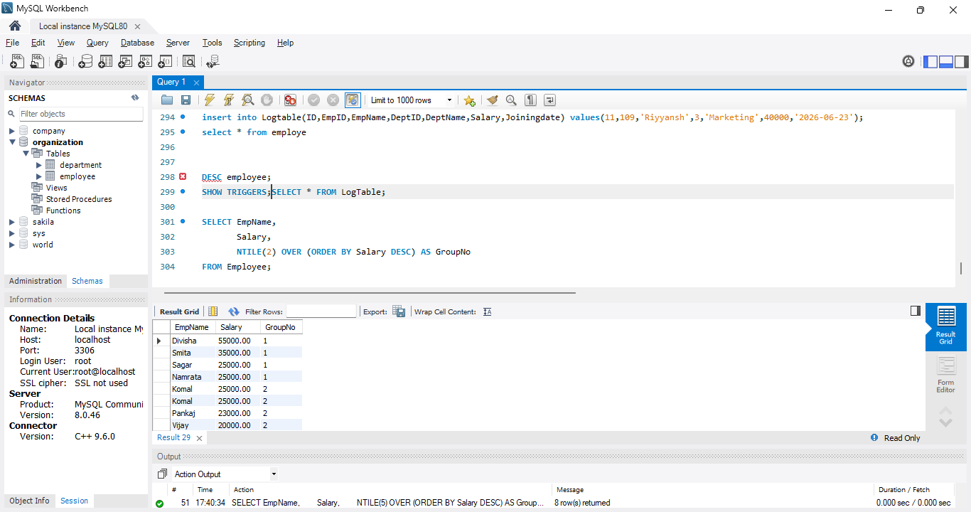

5} LEAD() returns the value from the next row in the result set."
SELECT EmpName, Salary,
LEAD(Salary) OVER (ORDER BY Salary) AS NextSalary
FROM Employee;
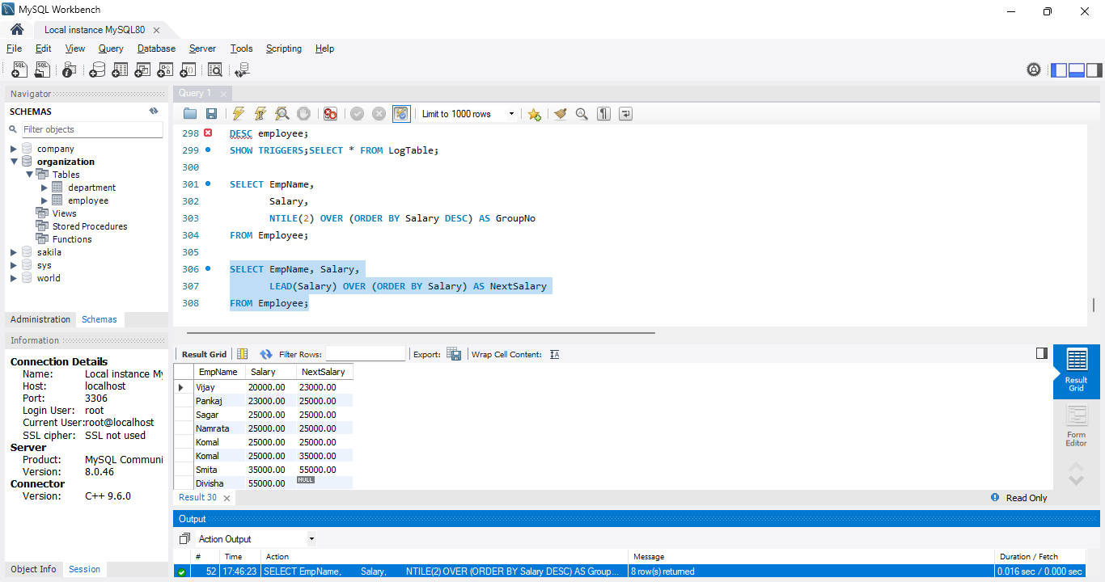

6}LAG() returns the value from the previous row in the result set."
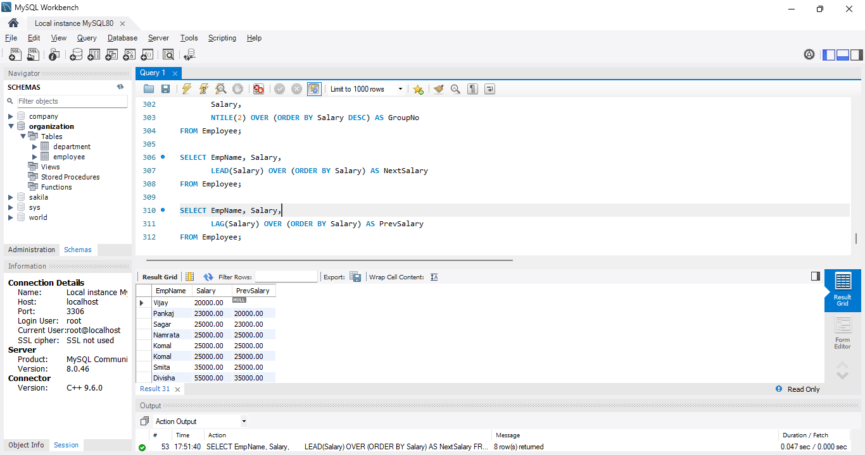

7]First _Value("FIRST_VALUE() returns the first value in the window partition.")
SELECT EmpName,
Salary,
FIRST_VALUE(Salary) OVER (ORDER BY Salary DESC) AS HighestSalary
FROM Employee;
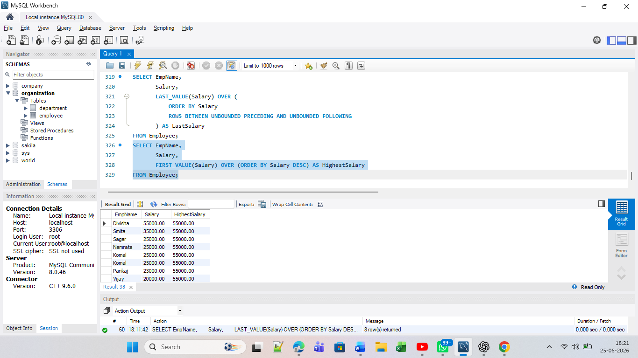

8} "LAST_VALUE() returns the last value in the window partition."

SELECT EmpName,
Salary,
LAST_VALUE(Salary) OVER (
ORDER BY Salary DESC
ROWS BETWEEN UNBOUNDED PRECEDING AND UNBOUNDED FOLLOWING
) AS LastSalary
FROM Employee;
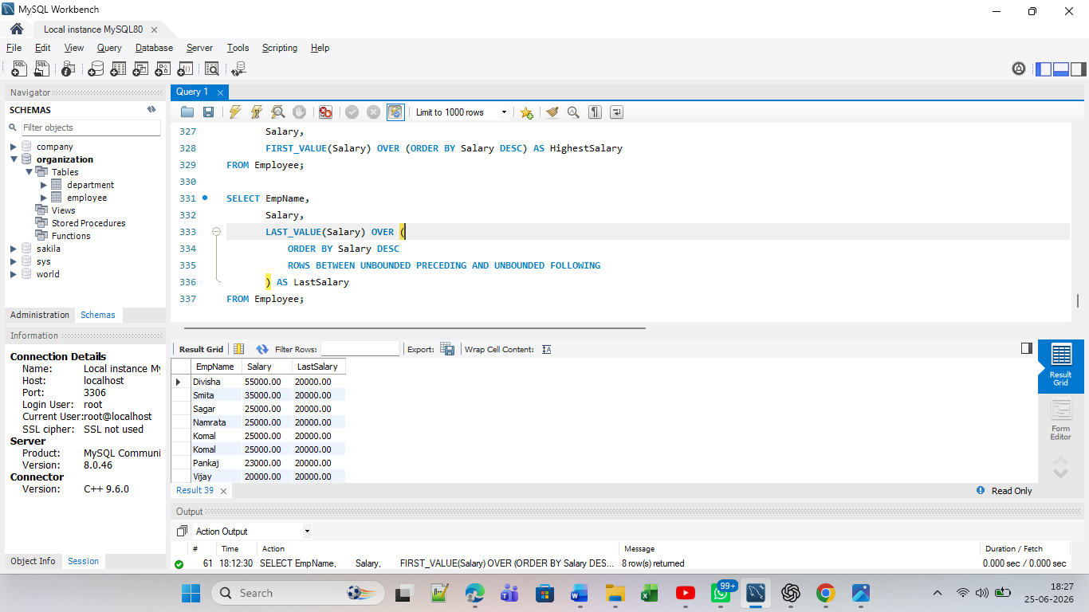

9}Nth value("NTH_VALUE() returns the value from the nth row in the window.")
SELECT EmpName,
Salary,
NTH_VALUE(Salary, 2)
OVER (
ORDER BY Salary DESC
ROWS BETWEEN UNBOUNDED PRECEDING
AND UNBOUNDED FOLLOWING
) AS SecondHighestSalary
FROM Employee;
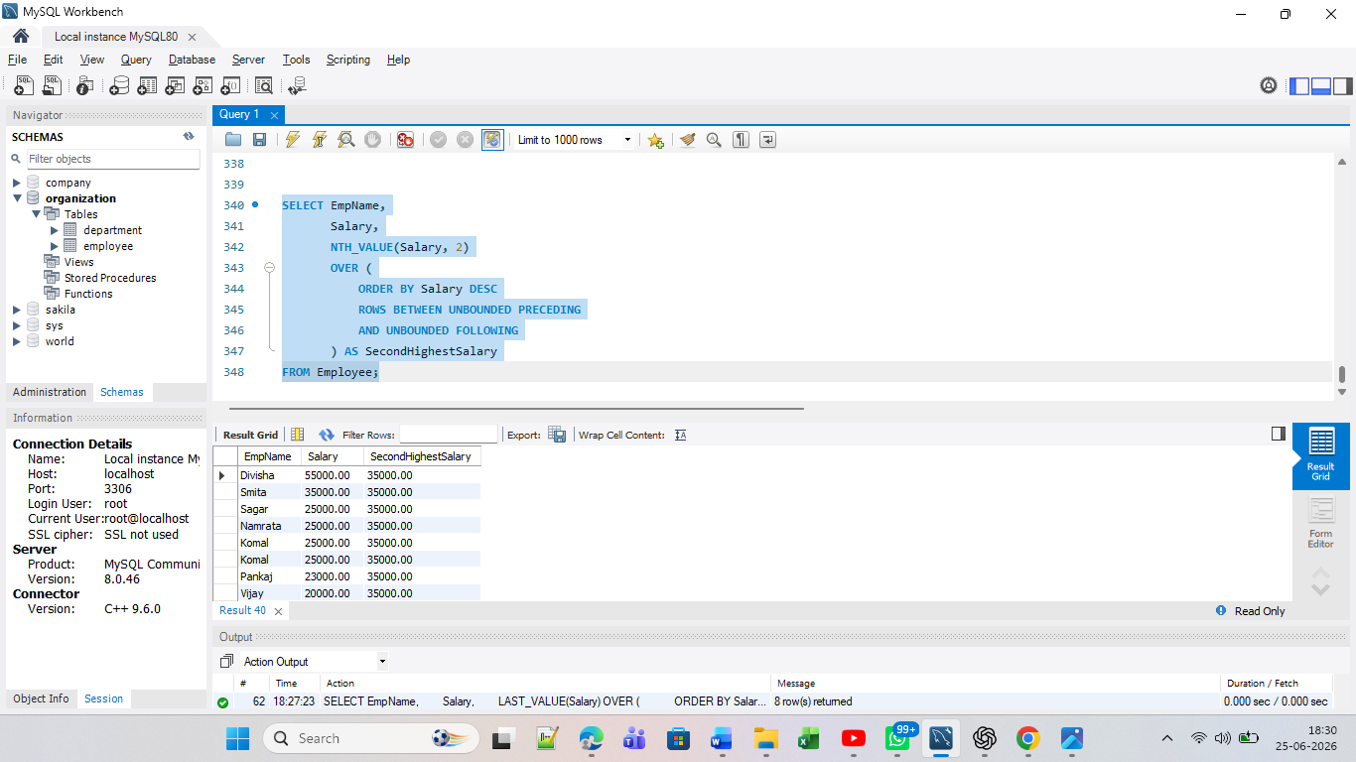
View:( Views are used to show required data, simplify complex queries, and restrict access to sensitive data.")
3. Apply View on the data

- CREATE VIEW Employee_View AS
SELECT EmpID, EmpName, Salary
FROM Employee;

- SELECT * FROM Employee_View;
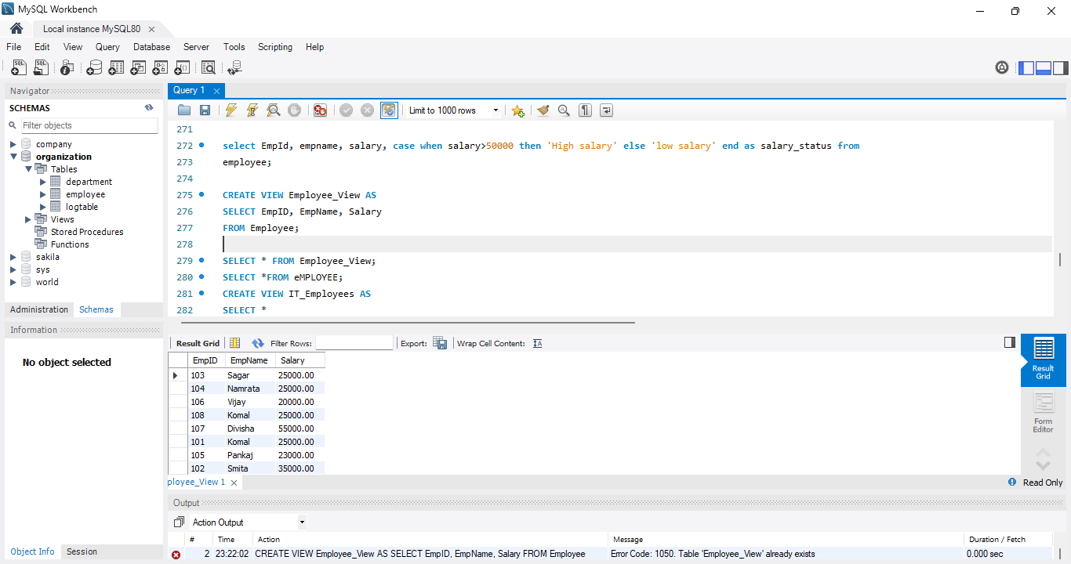

Trigger on data: A Trigger is a special database object that automatically executes when a specific event occurs on a table.
create trigger emp_insert_trigger
after insert on employee
for each row
insert into Logtable(Message)
Values('New Employee inserted');

insert into Employee(ID,EmpID,EmpName,DeptID,DeptName,Salary,JoiningDate) Values(15,112,'Riya',1,'HR',30000,'2026-06-25');
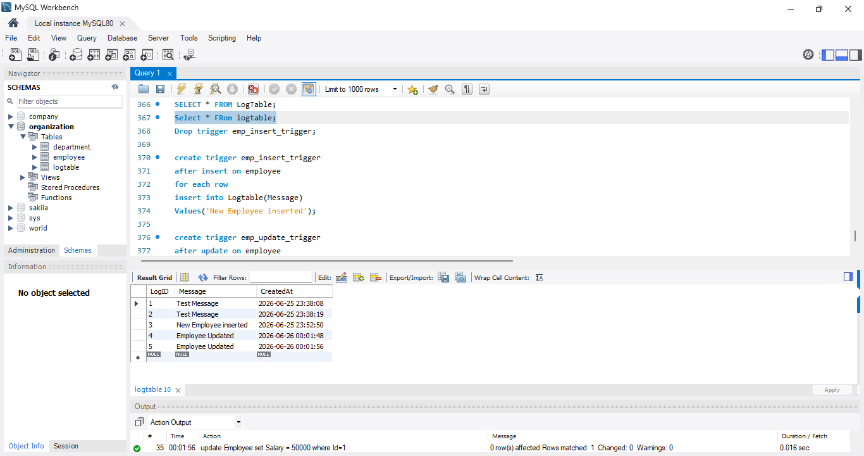

Update trigger:
create trigger emp_update_trigger
after update on employee
for each row
insert into Logtable(Message)
Values('Employee Updated');

update Employee set Salary = 50000 where Id=1;


For_delete records trigger:
create trigger emp_delete_trigger
after delete on employee
for each row
insert into Logtable(Message)
Values('Employee Deleted');

delete from Employee where ID=8;
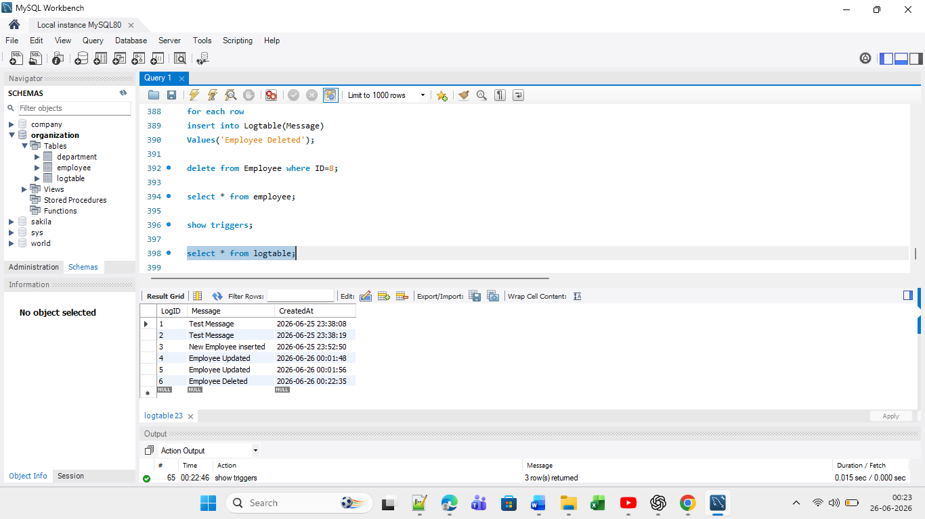

Before trigger called

DELIMITER $$

CREATE TRIGGER trg_before_insert
BEFORE INSERT
ON Employee
FOR EACH ROW
BEGIN
IF NEW.Salary < 0 THEN
SIGNAL SQLSTATE '45000'
SET MESSAGE_TEXT = 'Salary cannot be negative';
END IF;
END $$

If we enter negative salary then it shows error message.

INSERT INTO Employee
(ID, EmpID, EmpName, DeptId, DeptName, Salary, JoiningDate)
VALUES
(16, 110, 'Amit', 2, 'Sales', -5000, '2026-06-25');

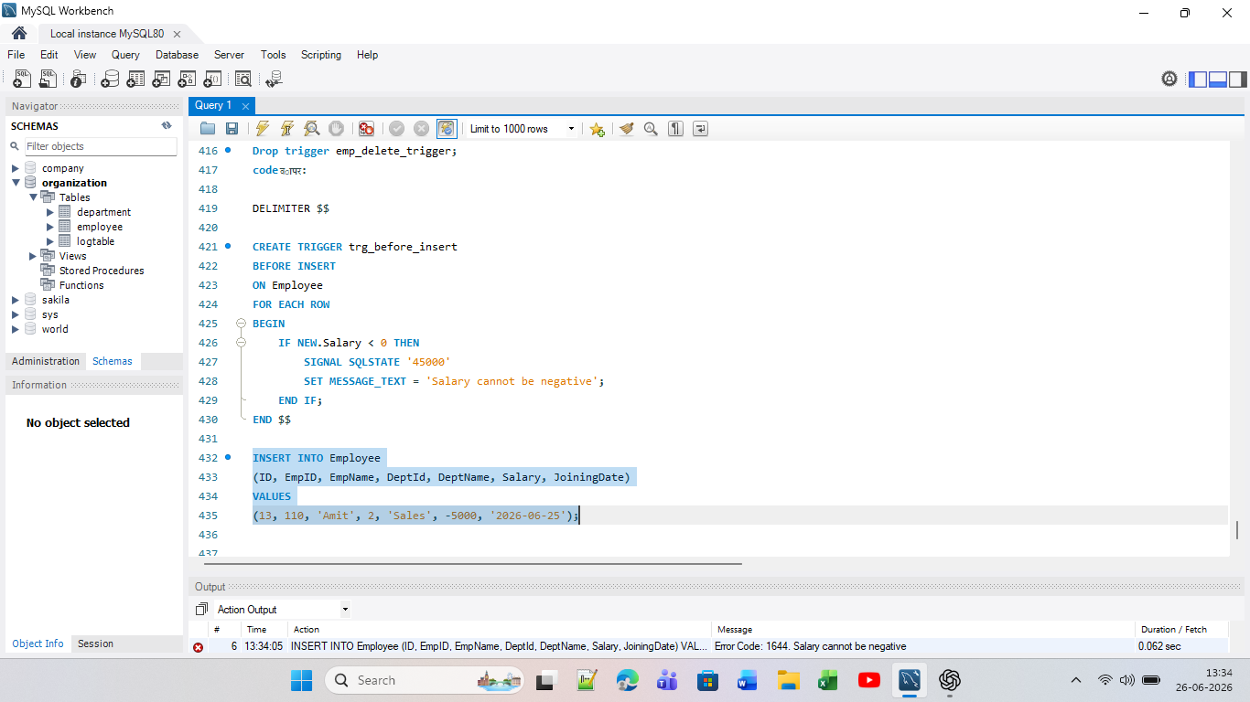

5. Handle Case When in the data
select EmpName ,salary ,
case
when salary<30000 then 'Low'
when salary between 30000 and 50000 then 'Medium'
else 'high'
end as salary_level
from employee;

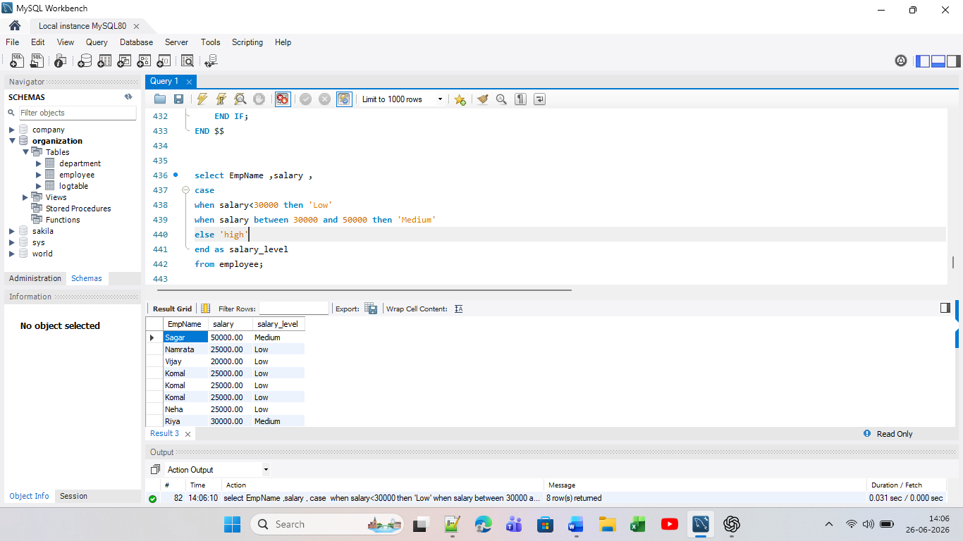

Eg 2:
SELECT EmpName,
DeptName,
CASE
WHEN DeptName = 'HR' THEN 'Human Resources'
WHEN DeptName = 'IT' THEN 'Information Technology'
when DeptName = 'QA' then 'Quality Assurance'
ELSE 'Other'
END AS Department_Name
FROM Employee;
